Spring Cleanup Made Easy with Green Waste Service

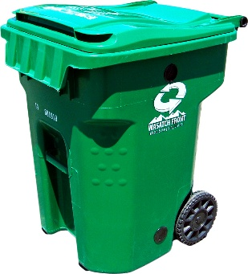
Spring is here, lawns are waking up, and yard work is back. To help residents manage seasonal yard and garden waste, Wasatch Front Waste and Recycling District’s Green Waste Can service begins Monday, March 9, and runs through Friday, December 11.

The Green Waste Can is designed for common yard materials such as grass clippings, leaves, garden debris, and small branches. This subscription-based program helps to keep these materials out of the landfill and frees up space in your regular trash container.

All green waste is delivered to the Salt Lake County Landfill composting facility, where it is processed into USCC-certified compost available for public purchase, supporting a local circular economy. Download our new Green Waste Can Guide here.

The Green Waste Can is also a cost-effective alternative to adding another garbage can:
- Green waste can: $12.00 per month
- Additional garbage can: $19.50 per month

Learn more and sign up at:
https://wfwrdutah.gov/how-recycle/green-waste-101

Compost information is available at:
https://www.saltlakecounty.gov/landfill/compost/

Monthly Billing is here!

As of February, Wasatch Front Waste and Recycling District fully transitioned to a monthly billing schedule for all customers, replacing quarterly billing with a more predictable and consistent monthly billing cycle.

Residential service rates remain the same and this is not a fee increase; only the timing of your bill has changed. Each monthly bill covers the previous month’s services, breaking costs into smaller, more manageable payments throughout the year.

The $26.00 monthly base fee includes weekly 96-gallon garbage and recycling collection, along with several additional services provided at no cost, including:
- Bulky waste collection via the Seasonal Container Reservation Program (SCRP), typically performed from Mid-April through September
- Landfill vouchers for disposal of residential truck, car, or trailer loads
- Central glass drop-off locations and collection services
- Container repair and replacement (typically 5 to 7 business days)
- Seasonal central leaf bag drop-off program
- Seasonal curbside Christmas tree collection program
- One-Time Move-in Box Pickup
- In-house, Local Customer Service (M-F 8:00am - 4:45pm)

Now that monthly billing is in place, residents are encouraged to switch to paperless, electronic billing. e-Billing reduces paper use, eliminates mail-related energy use, helps lower billing costs, and provides faster access to bills and payment options.
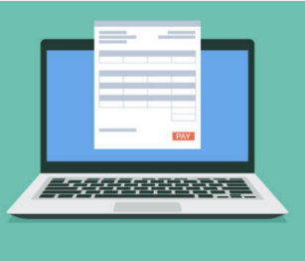
To sign up for paperless billing, visit: Paperless Sign Up | Wasatch Front Waste and Recycling District

