
Point & Pay - Payment Processing Vendor

Our new payment processing vendor, Point & Pay, went live during the month of May.
They were selected through a competitive Request for Proposals (RFP) process. Several vendors were evaluated based on functionality, implementation, customer service, security, and overall cost. Point & Pay was selected because it offered the best overall value and is expected to reduce payment processing costs by nearly $140,000 per year.

AutoPay Users - Action Required: Due to banking security and privacy requirements, the previous payment provider could not transfer customers' stored banking information or autopay authorizations, requiring customers to re-enroll.

While the District routes customers through our customer portal for convenience, you can access the Point & Pay landing page directly where you can sign in here: Wasatch Front Waste and Recycling District, UT Payments. Be sure to have your WFWRD account number ready.

Please consider signing up for electronic, paperless billing. You can also sign up for convenient automatic payments! You must have an existing account before you can sign in with Google or Facebook.

New Postcard Bill Format – Here’s How to Read It

1. Account Information: This section identifies the property receiving services, account number, and service period.
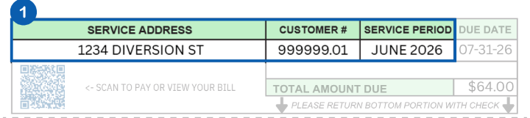

2. Current Billing Information: This area provides a snapshot of prior balance, current services charges, and any additional or subscription-based service charges.
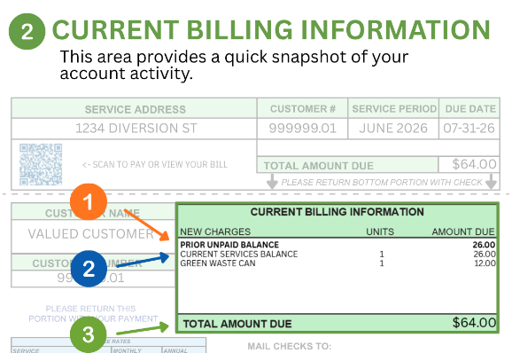
3-6. The remaining items provide further information on how to read our new postcard bills.

