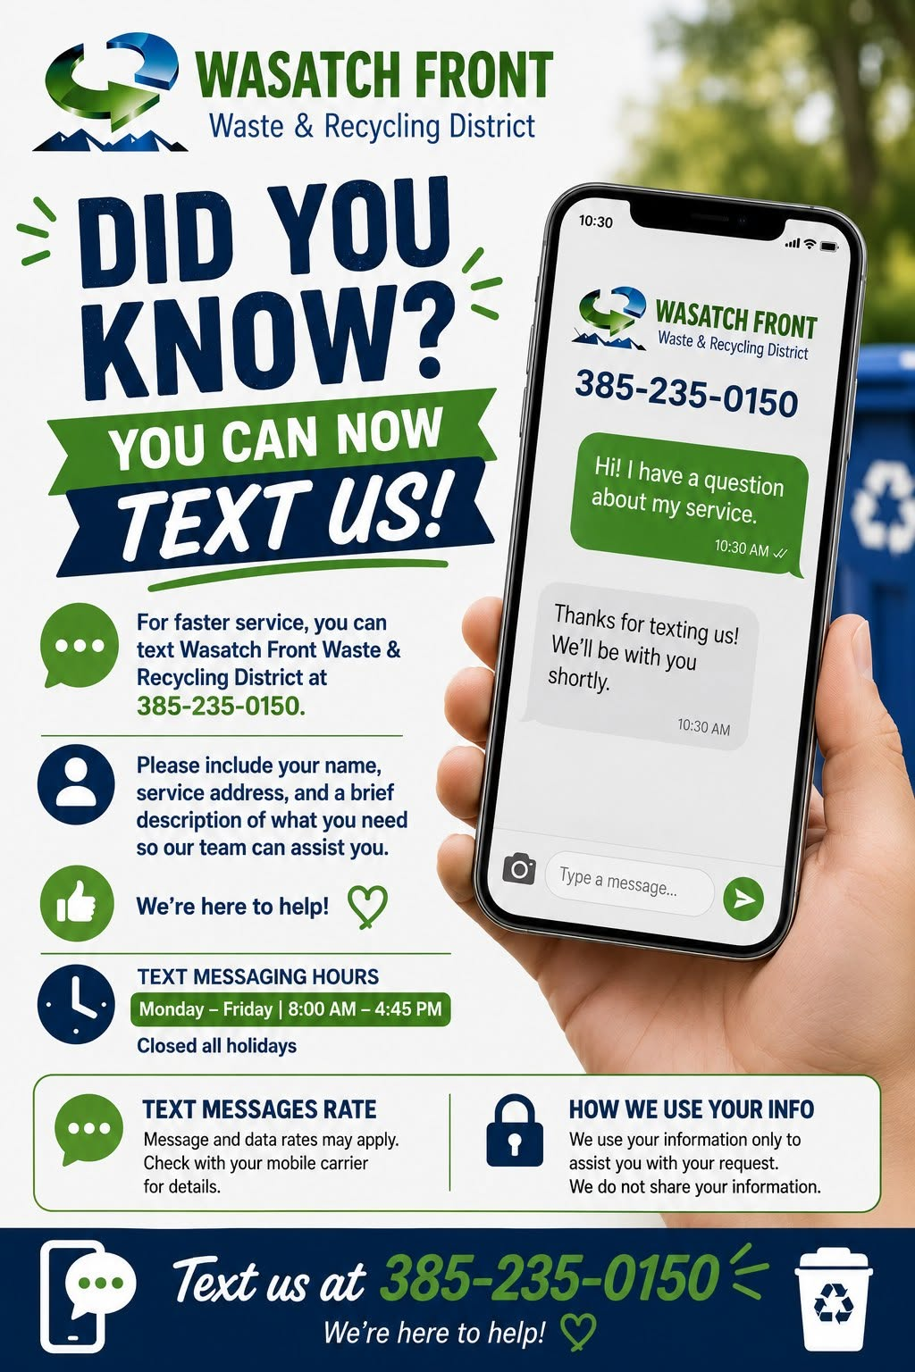
You Can Text Us Now!

We are excited to continue expanding the ways our customers can connect with us while providing a variety of communication options.

Customers can now send text messages to
(385) 235-0150

A Customer Solutions Specialist will respond directly to your message, providing a faster and more convenient way for you to get assistance during times of high call volumes. Text line hours are Monday through Friday 8:00am–4:45pm.

Many customers are already choosing text as their preferred method of communication.

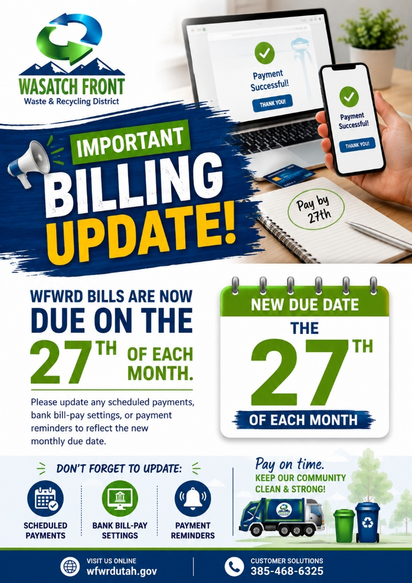

Bill Due Date Change

Beginning with your July bill, monthly due dates have changed from the last day of each month to the 27th of each month.

If your automatic payment through WFWRD’s payment processing provider, Point & Pay, is already scheduled to process on the due date, no action is needed.

If not, you may need to update your scheduled payments through any of the other payment providers you use to make sure your monthly payments are made on time, including bank bill-pay settings or payment reminders.

